**CTIS487 – Mobile Application Development**

**Project – Testing Report**

**2021-2022 Fall**

**Zeynep Göksu Üçüncüolu**

**İrem Civek**

After we test our application against multiple real mobile devices by using AWS Device Farm, we obtained a testing report. The application is tested on 4 different devices which are Google Pixel 3a, Google Pixel 3, Samsung Galaxy S21, Samsung Galaxy Tab S7 and from 12 different test cases, 8 of them (67%) is passed and 4 of them (33%) is failed.

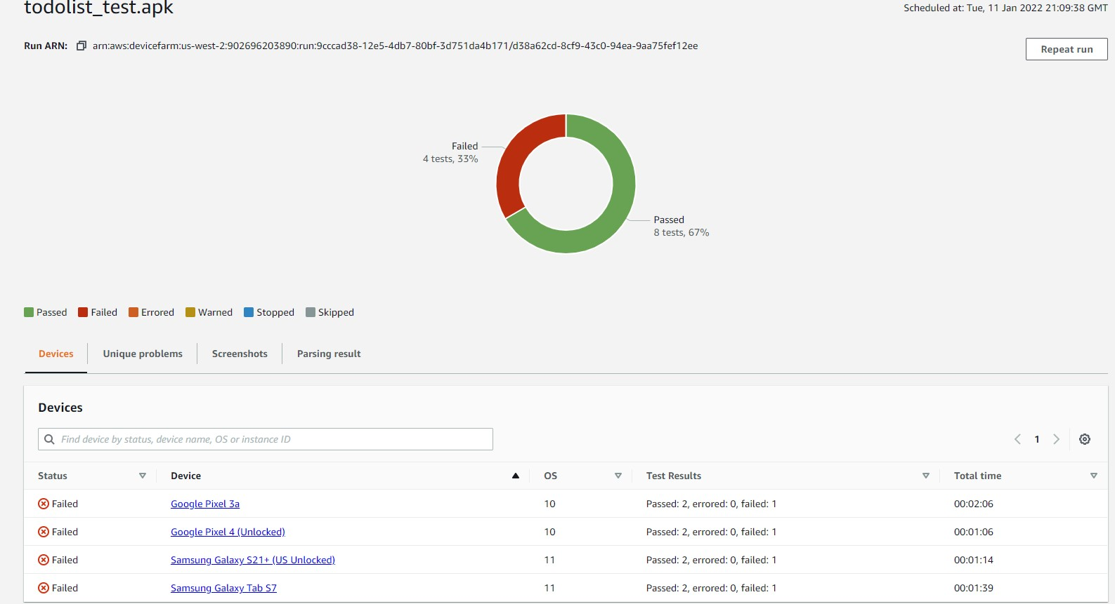

https://console.aws.amazon.com/console/home?region=us-east-1